

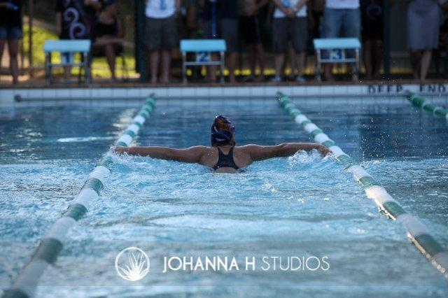**HANDBOOK**

Contents

Message from the President 1

Your Committee 2

Your Life Members 3

What’s on offer 4

Club Nights 5

Club Championships 8

Trophy Day 10

Friendly Carnivals 12

Sanctioned Carnivals 13

Club Calendar 15

Club Coaching and Learn to Swim 17

Club (Age) Records 20

Club Rules 27

Guidelines for Parents of Competitive Swimmers 28

Good Times….. 30



# Message from the President

Welcome everyone to the new swimming season.

Electric Eels Swim Club has been in existence since 1975 and our home is the Zillmere State School pool. In 2003 we became an incorporated association registered with the Queensland Office of Fair Trading.

We have a very proud history of providing fun and fitness through swimming for our children in our local community and this year is no different.

Through the hard work of our committee, generosity of our sponsors and our many partners & volunteers we have a calendar of events that will provide our members with substantial opportunity.

Our club is in very good shape, memberships continue to grow, our pool is both heated and painted and we have a new electronic semi-automatic timing system.

What sets us apart from other clubs is our friendly attitude in a relaxed atmosphere but most of all we get behind our kids.

My challenge to all our parent members is to increase the cheer for our kids – after all this is why we are here!

You will find everything you could almost ever need on our website [www.electriceels.org.au](http://www.electriceels.org.au) it is the communication backbone for our club and usually a very reliable communication tool.

I trust you and your family enjoy the season ahead!

# Your Committee

President Ken Eade 0477 742 852

Vice President Phil Bayliss 0419 780 856



Treasurer Sharon Burns 0411 644137

Secretary Lisa Furuya 0439 893 004

Race Secretary Kym Lucas 0413 867 712

Brad Lucas 0407 794 569

Carnival Manager Kate Vickers 0412 154 201

Fundraising Manager Kerry Jackson 0448 920 558

Louise Ferry 0413 485 781

Website Manager Jason Aquilina 0405 082 365

Canteen Manager Rebecca Davis 0419 672 290

# Your Life Members

*Colin Noonan 1984*

*Keith McDowall 1986*

*Dawn McDowall 1986*

*Val McDonald 1989*

*Glenda Marshman 1989*

*Barbara Collyer 1990*

*Alan Menelaws 1991*

*Kay Menelaws 1991*

*Sean Brown 1992*

*Merv Smith 1992*

*Lucy Smith 1995*

*Alex McNaughton 1995*

*Norma McNaughton 1995*

*Heather Hawkes 1999*

*Greg Seaborn 2001*

*Carmel Stephens 2004*

*Leigh Watson 2005*

*Greg Gardiner 2005*

*Trevor Watson 2006*

*Neil McDonald 2006*

*Debbie McDowall 2012*

*Jackie Blackshaw 2014*

Thankyou for your continued support!

# 

# E:\Old Computer 13.7.13\Swimming Club\2012-2013\Dept of National Parks, Recreation Sport and Racing 2012\Photos\JHS -0149.jpgWhat’s on offer

Our Club functions to provide opportunities for our kids of all abilities. It does not matter what your goals are we have something for you;

# Club Nights

The main event – we meet every Friday night in the school terms 4 and 1 to compete against yourself.

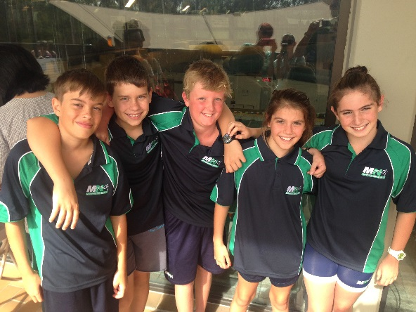

**Typical Program**

|  |  |
| --- | --- |
| 6.00 | Arrival / Nominations |
| 6.15 | Nominations Close |
| 6.30 | 12.5m Freestyle  25m Freestyle  50m Freestyle |
| 7.50 | 12.5m Backstroke  25m Backstroke  50m Backstroke |
| 7.10 | 12.5m Breaststroke  25m Breaststroke  50m Breaststroke |
| 7.30 | Break for BBQ dinner |
| 7.50 | 12.5m Butterfly  25m Butterfly  50m Butterfly |
| 8.10 | 100m Individual Medley (4 x 25m) |
| 8.30 | Finish |

Our automatic timing system records your personal best times and once you swim fast enough you can challenge yourself at the longer distance.

**Points System**

Once a personal best (PB) time is recorded in each recognised stroke for each distance your improvement is measured in points by comparison with your PB time.

The points system rewards consistency and continuous improvement - Points are calculated as follows:

1 point more than 2.5sec SLOWER than PB time

2 points between 1.6 and 2.5 sec SLOWER than PB time

3 points between 0.6 and 1.5sec SLOWER than PB time

4 points 0.5sec FASTER or SLOWER than PB time

5 points 0.6 (or more) FASTER than PB time

**\*To be able to participate in the events, the swimmers must nominate for them at the start of the night.**



# Club Championships

Eligibility;

1. Club members joining at the beginning of the season (prior to 12th October 2014) must swim 50% of all swims that they are eligible for. For example, if there is 20 available club nights then you must swim 10 or more swims in each stroke you wish to compete at during club championships.

2. Swimmers joining the club during the season (after 29 January 2015) must swim at least 50% of all swims that they are eligible for. To be eligible for club championships you must swim at least 6 swims in the strokes you wish to compete in. For example, if your first club night is week six of the season then you must swim at least 7 swims in each stroke you wish to compete at during club championships.

3. To be crowned age champion you must compete in all strokes at club championships.

4. Cancellations due to weather will not be counted as an available week.

5. Swimmers that notify the club that they are suffering from an injury, at the club committee’s discretion, those weeks may not be deemed to count as eligible weeks.

Age for club championships will be the swimmers age on the 1st night of the championships.

NOTE: MEDLEY WILL START AT 7 YEARS AND OVER. OTHER DISTANCES WILL BE ANNOUNCED DURING THE SEASON.

If you do not understand the above eligibility rule please discuss it with the President or the Race Secretary.



**Thankyou to our partners!**

# Trophy Day

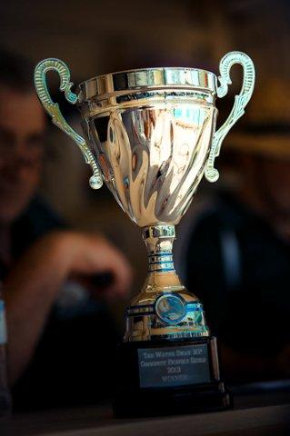 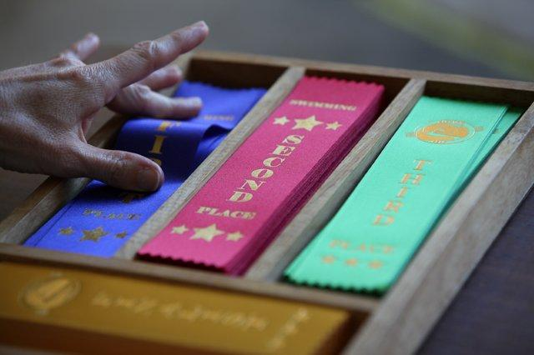

 A trophy presentation is conducted at the conclusion of the club championships. The presentation is designed to recognise all types of wonderful achievements by the kids throughout the season.

Life Members are invited to present their perpetual trophy to the new generation of swimmers from our club.

Whilst Age Champions are recognised and rewarded with a Gold, Silver or Bronze medal members also have an opportunity to win a number of other different trophies;

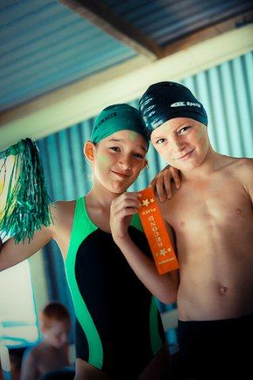 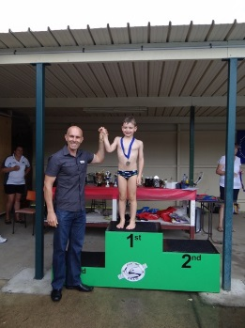 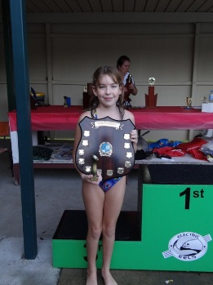

Last Years Winners….







**Thankyou to our sponsors!**

# Friendly Carnivals

We schedule 2- 4 friendly carnivals every season. We ask that all members compete in at least one friendly carnival each season.

There are a number of perpetual trophies that the club has been part of for many years. They are typically held on a Saturday Afternoon at 2.00pm and go for about 3 hours.

A rotation system exists amongst our friendly clubs – we generally take it in turns to host the carnival. This means we are sometimes guests at other venues.

Some examples of our traditional competition include;

*Aspley, Geebung, Craigslea, Stafford, Virginia, Wavell Heights, and Wooloowin.*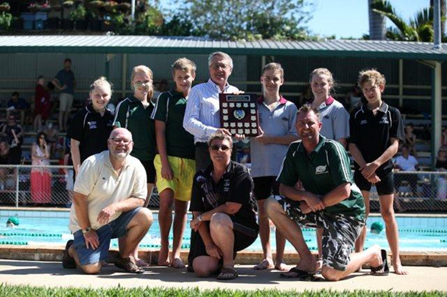

Sanctioned Carnivals

A sanctioned carnival is regulated by Swimming Queensland. They typically are broken into 3 categories in the Brisbane Region;

* Introductory Meet
* Development Meet
* A Grade Meet

These are typically hosted by clubs that are affiliated with Swimming Queensland. Our club is affiliated and we regularly compete - they are typically scheduled on most Sundays and occasionally Saturdays throughout the season.

These will interest the competitive squad swimmers and provide an opportunity to compete in both Regional and State Championships.

Swimmers whom wish to compete in Regional and State Championships will need to register a qualifying time at a sanctioned carnival to be eligible.

Swimmers at these meets represent our club, accordingly we request that your wear your club competition cap and club shirt with pride at every meet.

Brisbane Swimming Association run a points competition to recognise and reward affiliated clubs of their achievements throughout the year.

Swimming Australia (with Swimming Queensland) run a JX and YPS program to recognise and reward individual achievements.

To learn more about the sanctioned carnivals visit the happening calendar at;

<http://qld.swimming.org.au/article.php?group_id=1210&id=122>

and;

<http://www.brisswim.org.au/#!2014-2015-approved-club-meets/c159c>

We typically send a copy of the program / flyer for each carnival as they are released by the host club – if you would like to see these emails make sure you tick the box on your membership form.

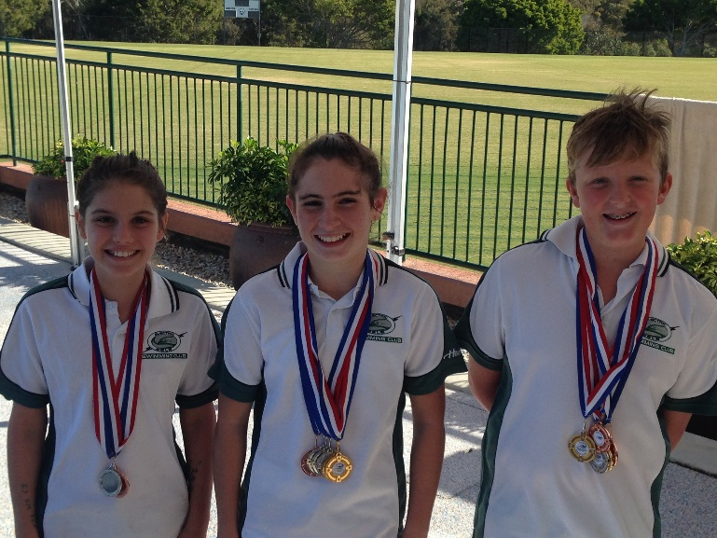

# Club Calendar

**30/31st August 2014 Qld State SC Championships**

13th September 2014 Sign On Day

14th September Development Meet (Australian Crawl)

10th October 2014 First Club Night

18/19th October 2014 A Grade (East Brisbane, Lawnton or Redcliffe)

25th October 2014 Friendly Carnival (tbc)

**31/2nd November 2014 Brisbane Snr Champs**

8/9th November 2014 A Grade (Acacia, Carina, Bayside or River City Rapids)

15th November 2014 (tbc) Development Meet (EESC)

22/23rd November 2104 A Grade (Chandler, Ferny Hills, St Peters West or Yeronga)

5th December 2014 Xmas Breakup

**13-19th December 2014 Qld State LC Championships**

24/25th January 2015 A Grade (Commercial or Nudgee Brothers)

30th January 2015 Return Club Night

7th February 2015 Friendly Carnival (option)

**7/8th February 2015 Brisbane Sprint Champs**

14/15th February 2015 A Grade (Albany Creek, Logan or Rackley)

**21/22nd February 2015 Qld State Sprint Championships**

28/ 1st March 2015 A Grade (Australian Crawl or Redlands)

7th March 2015 Friendly Carnival (option)

**7/8th March 2015 Brisbane Jnr Champs**

14th March 2015 Friendly Carnival (option)

**21st March 2015 Brisbane Relay Champs**

27th March 2015 Final Club Night

28th March 2015 Club Champs & Presentation

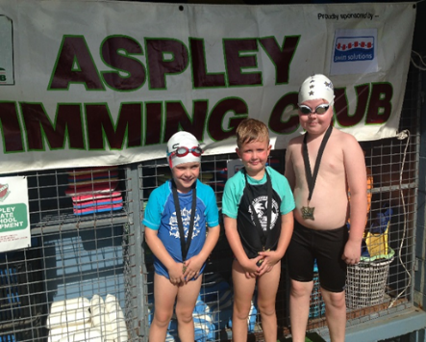 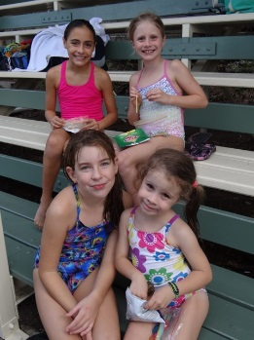

# Club Coaching and Learn to Swim



In partnership the electric eels swim club, Healthstream provide a full program of coaching and learn to swim at our heated club swimming pool.

The head coach will provide free assessments to advise the best squad or class for each individual. As a guide;

Senior Squad

These members are typically 10 years and older with a goals and ambitions to be selected in the Metropolitan North regional team or the Qld state team in the schools competition.

In addition, these members will have goals to represent the club and qualify for both the Brisbane and QLD championships.

Senior squad members are encouraged to swim a minimum of 5 times per week to a maximum of 11 times per week.

They are also encouraged to represent the club in a minimum of 3 sanctioned carnivals (A Grade Meets) and one friendly carnival.

Junior Squad

These members are typically 8 years and older with goals and ambitions to be selected in the Bramble Bay district team in the schools competition.

Junior squad members are encouraged to swim a minimum of 3 times per week to a maximum of 6 times per week.

They are also encouraged to represent the club in a minimum of 2 sanctioned carnivals (Development Meets) and two friendly carnival.

Learn to Swim

*LTS is a four level program;*

*Level 1 –* Safe pool entry and exit, Unaided kick with board, both front (10m) and back (5m), Unaided streamlined kicking on front (rocket) for 5m, Assisted freestyle demonstrating ‘big arms over’, Assisted kicking on back (arms by side) for 5m, Front and back float for 10 seconds, Unassisted deep water entry and return to pool side, Assisted duck-dive to retrieve a submerged object from the shallow end (with and without goggles).

*Level 2* - Unaided kick with board, both front and back for 20m, Strong streamlined kicking on front (rocket) for 10m, Kicking on back (arms by side) for 10m, Freestyle with good technique and stable body position for at least 12.5m, Demonstrate side breathing consistently every third stroke, Backstroke for 10m, Front and back float for 10 seconds, Deep water jump and return to pool side unaided, Tread water unassisted for 10 seconds, Assisted duck-dive to retrieve a submerged object from the shallow end (with and without goggles)

*Level 3* - Freestyle & side breathing every 3 strokes for 25m, Backstroke with strong kick and straight arm recovery for 25m, Perform correct breaststroke kick for 15m – heels in, toes out, streamlined recovery & strong glide, Demonstrate correct breaststroke pull as an isolated skill, Demonstrate butterfly kick for 10m, Tread water for 30 seconds, Deep water jump and return to pool side unaided, Unassisted duck-dive to retrieve a submerged object from shallow end (with and without goggles), Perform a kneeling dive at the deep end of the pool

*Level 4* - Demonstrate streamlined starts and finishes, Swim 50m freestyle – side breathing every 3 strokes, maintaining correct body position, Demonstrate a freestyle tumble-turn, Swim 25m backstroke – strong kick and straight arm recovery, maintaining correct body position and timing, Perform 25m breaststroke – correct kick, maintaining correct body position and timing, Demonstrate 10m butterfly – Straight arm recovery, correct head and body position and correct rhythm, Tread water for 60 seconds and return to pool side unaided, Retrieve a submerged object from the deep end of the pool, Perform a standing dive at the deep end of the pool, Demonstrate sculling on back for 10m, Demonstrate swimming 2 survival strokes.



These members are typically 3 years and older with goals and ambitions to be just like their older brother or sister or neighbour in the Junior or Senior squads.

Learn to Swim members are encouraged to swim a minimum of 2 times per week to a maximum of 3 times per week.

They are also encouraged to participate in club nights in any stroke they feel comfortable with as well as a friendly carnival or two.

Learn to swim in Level 4 (7 years and older) are encouraged to participate in a sanctioned (Introductory) meet to learn how to race.

# Club (Age) Records

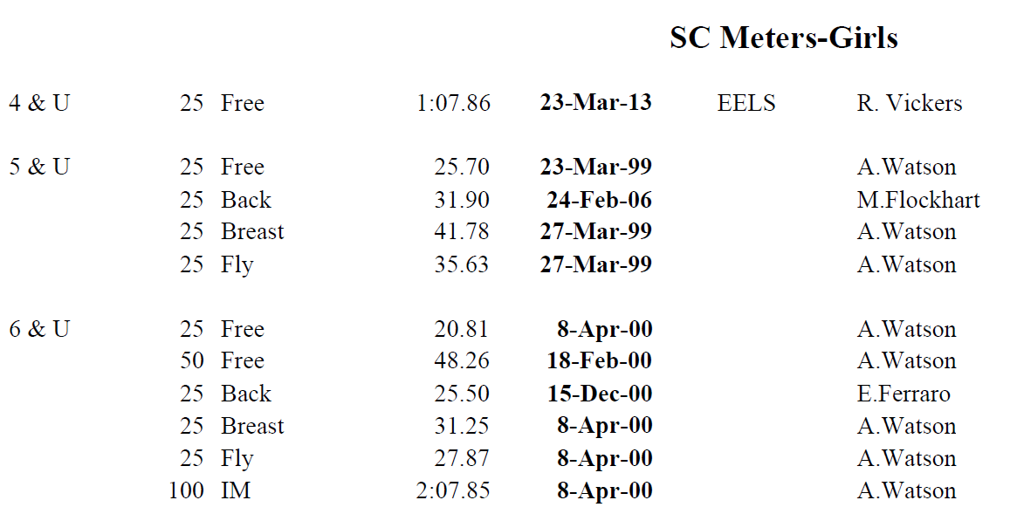

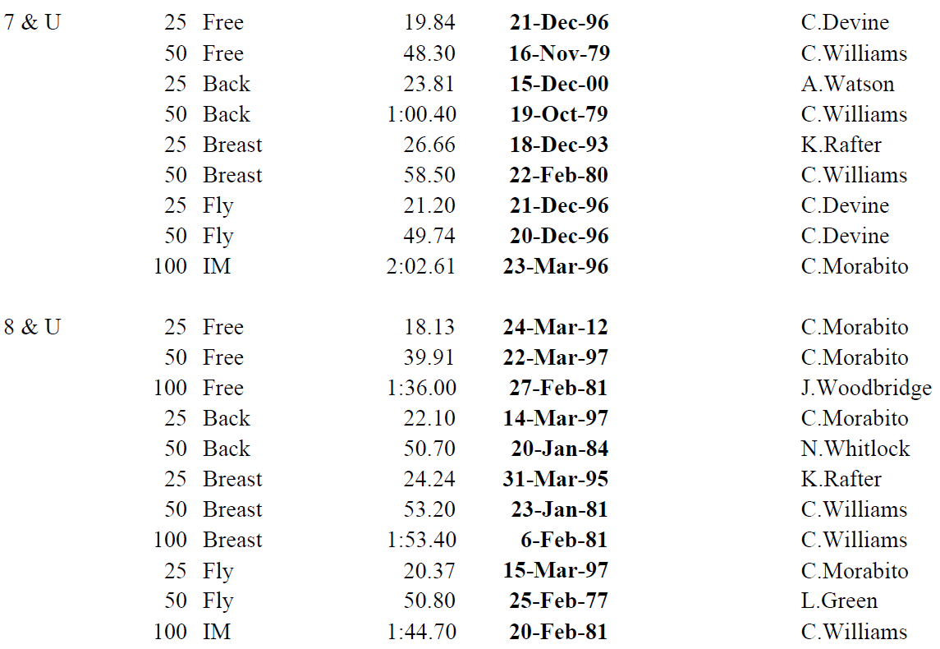

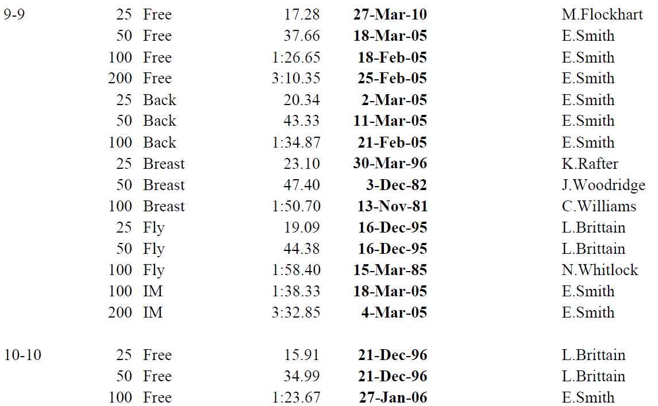

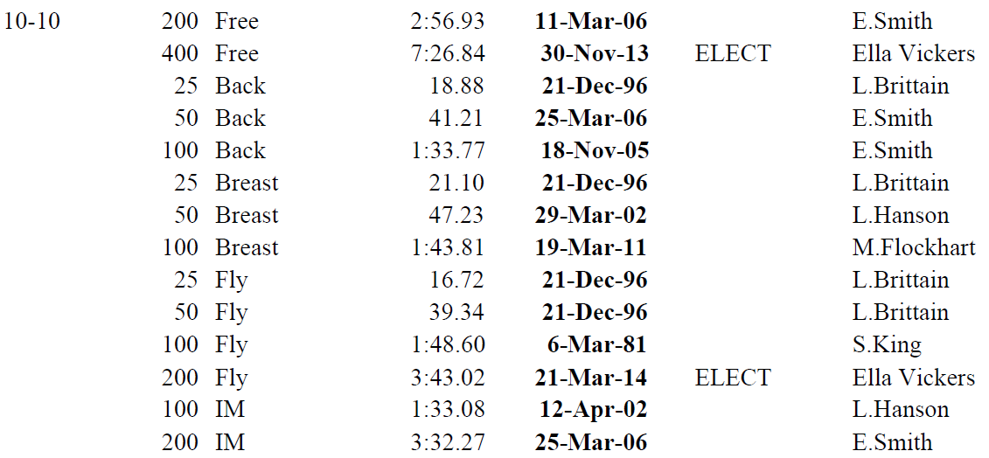

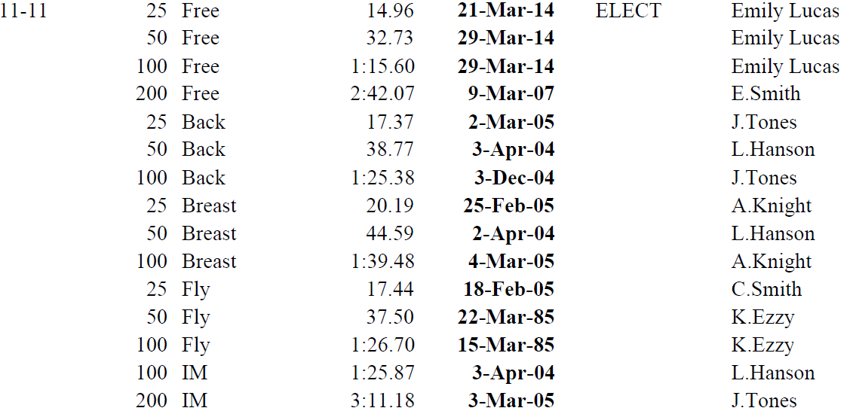

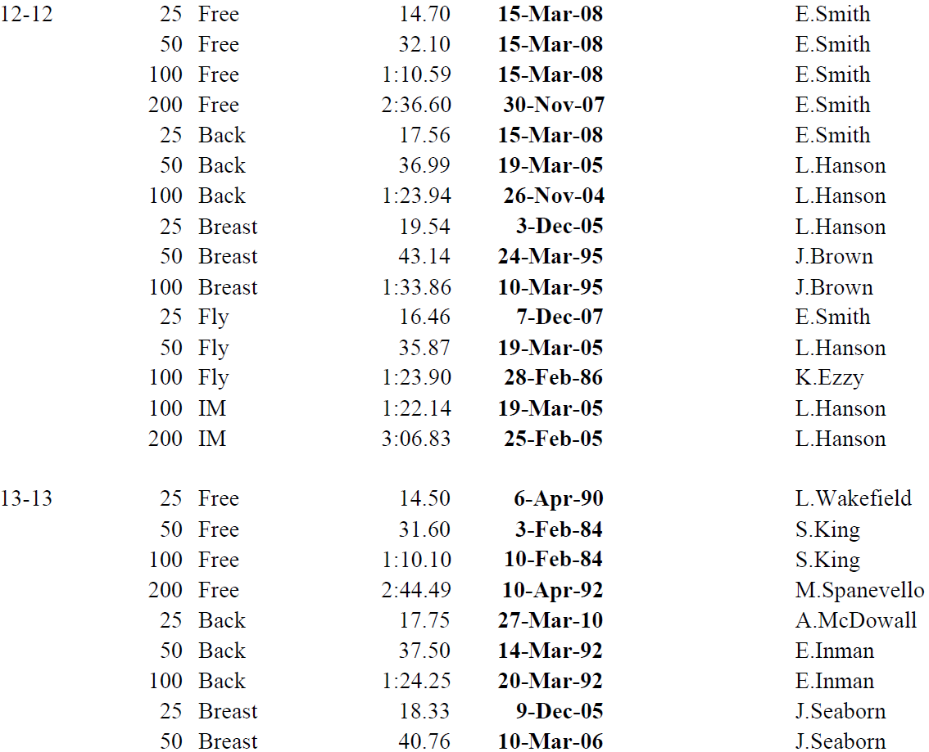





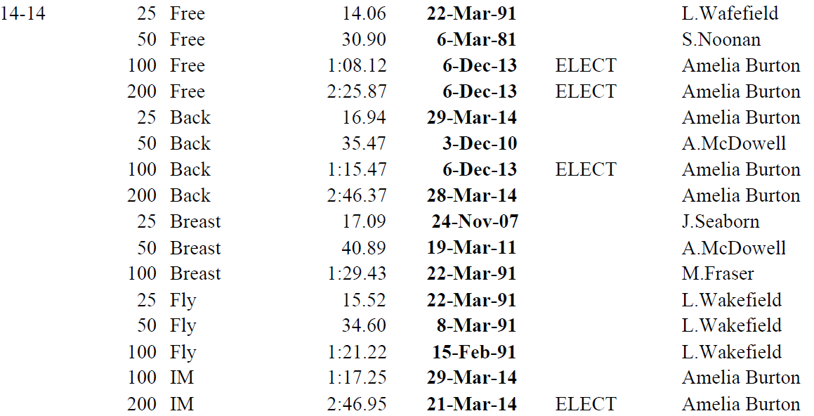

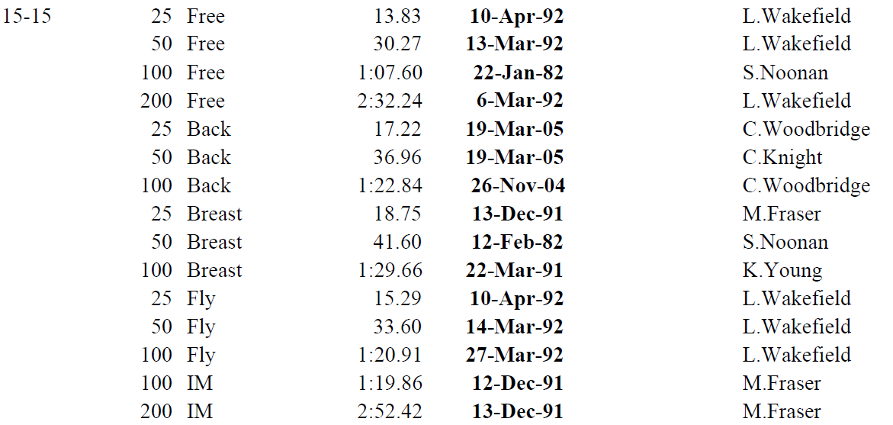

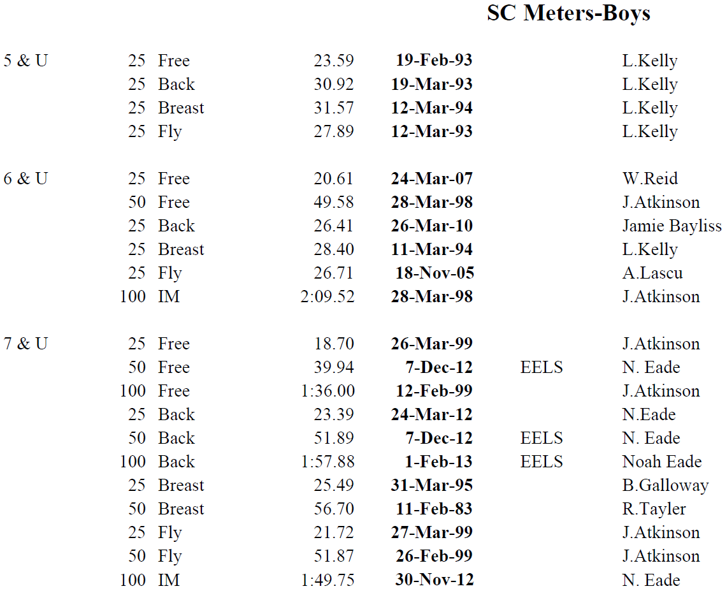

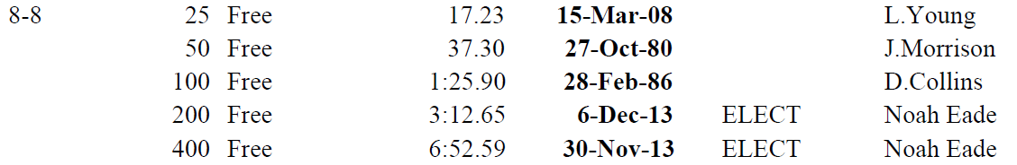

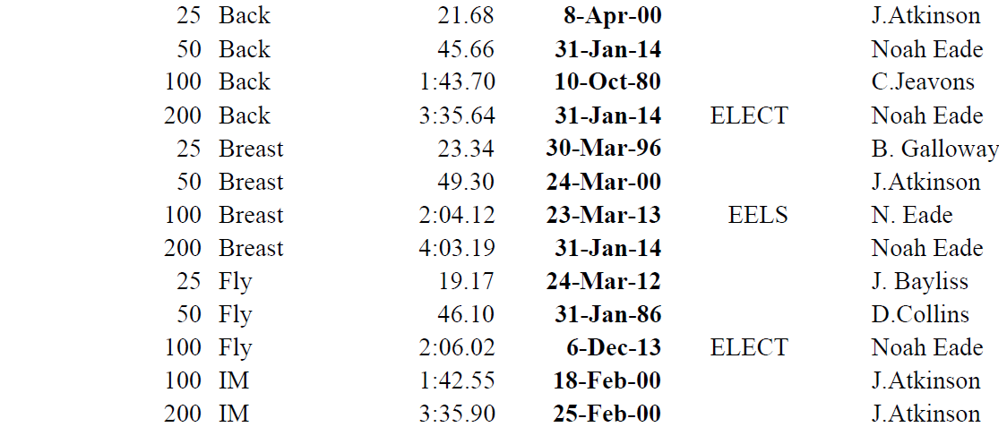

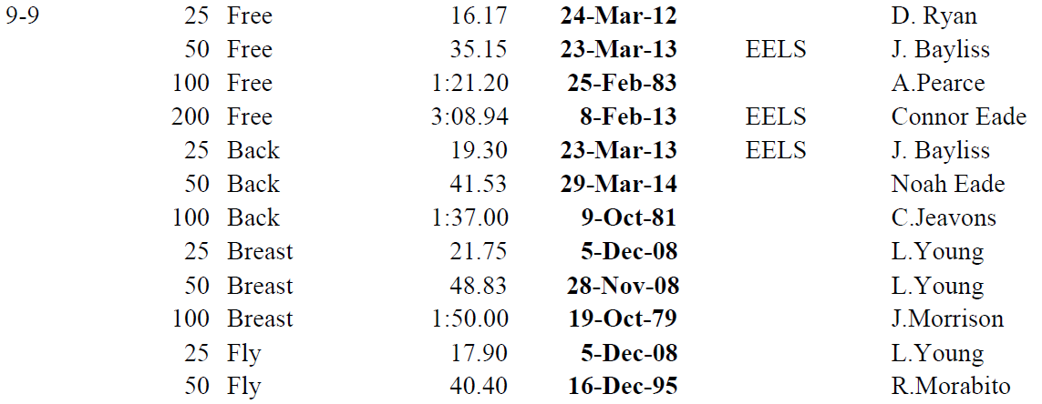

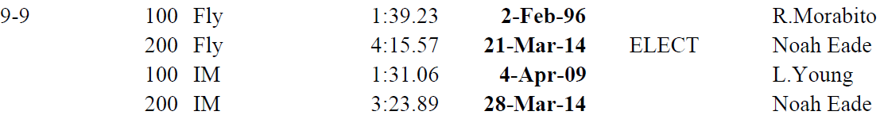

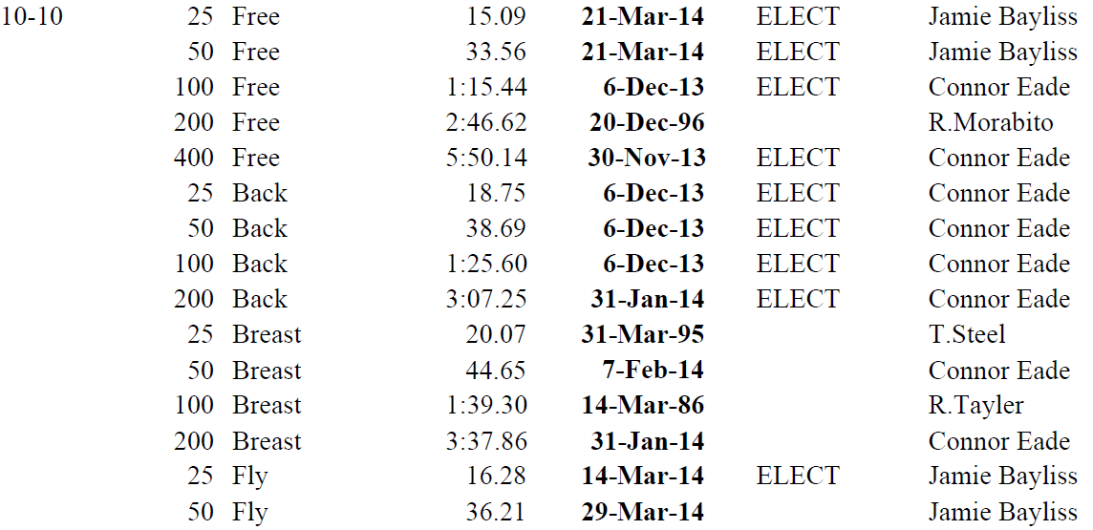

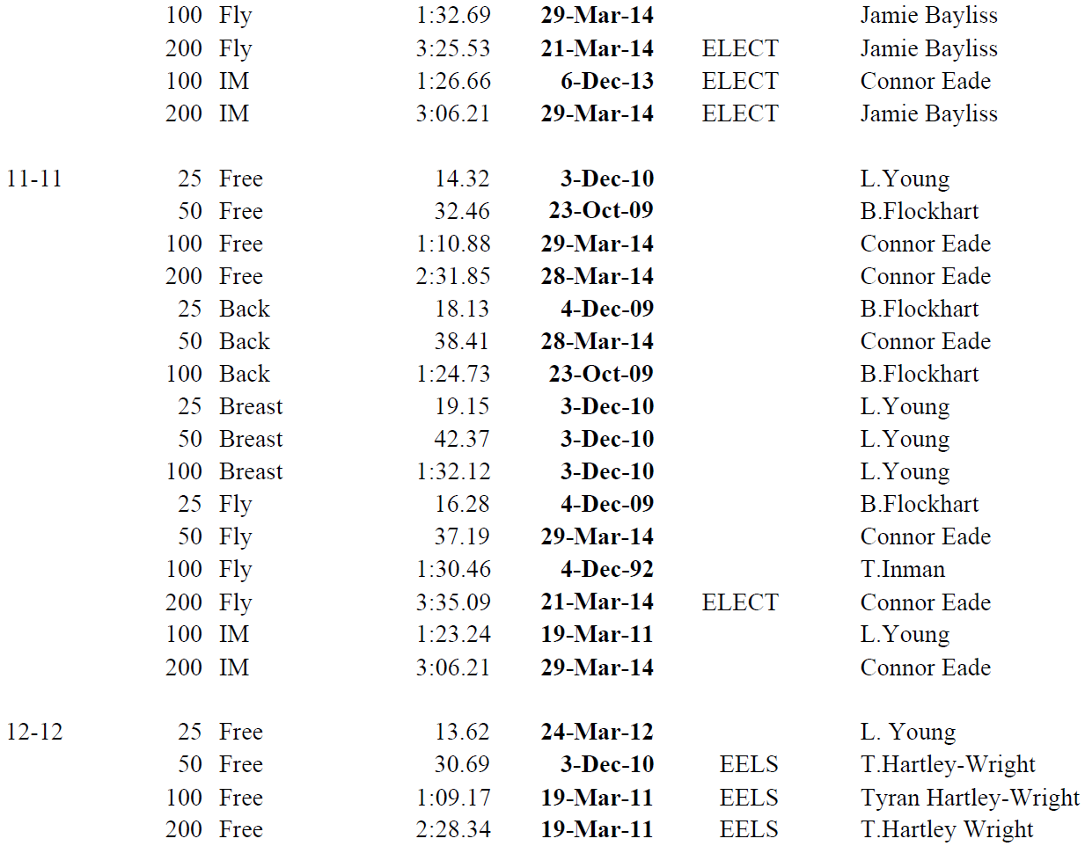

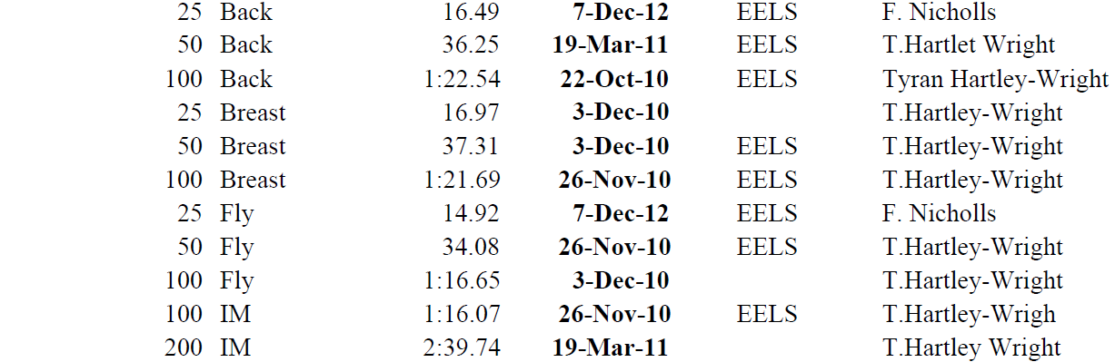

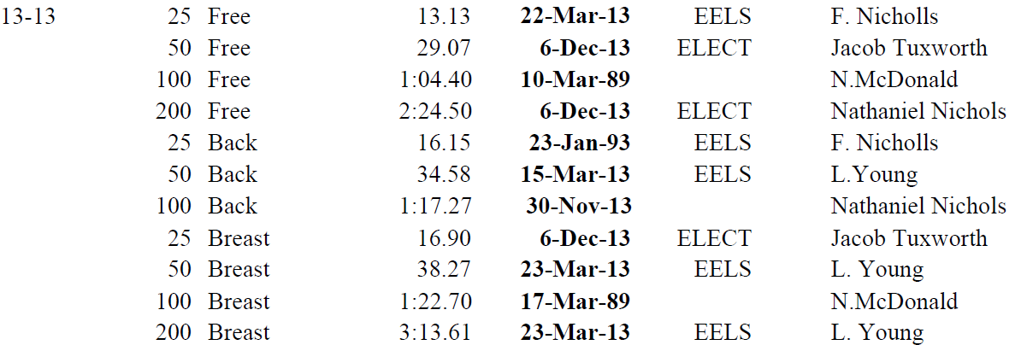

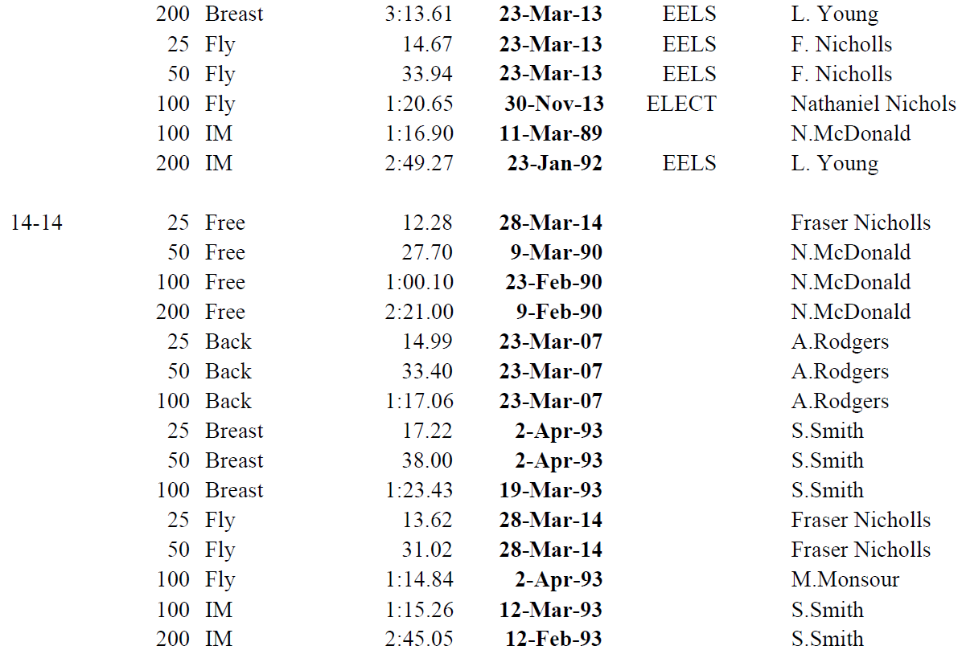



Thankyou to our sponsors!

# Club Rules

The following rules are designed to allow the club to function effectively on club nights, training sessions and carnivals.

1. A parent or responsible person must accompany children to all club activities, eg. club nights, family days, BBQ's and club break ups.

2. Children must at all times obey the instructions of club officials

3. No misbehaviour to the discomfort of others will be allowed

4. No child with open cuts, sores, illness or bandages will be allowed in the pool

5. All members must wear bathing caps when swimming. Hair pins and ribbons are not to be worn whilst in the pool.

6. No running or playing games within the pool enclosure.

7. Valuable items are not to be left in the change rooms.

8. No jumping or diving into the pool, except by special permission.

9. In the event of storms cancelling the latter part of club night, all unattached children will be asked to leave the pool area and officials will not be held responsible for the safety of the children.

10. If your child is hurt and the club has to call an Ambulance/Doctor in your absence, the club will choose the doctor and your absence will be taken that you are agreeable to this action.

11. The swimmer must make nominations for club swims personally.

12. If a swimmer nominates for an event and doesn't swim it, he/she will lose one point for that event.

13. All swimmers are called twice prior to an event. They must be ready to move to the starting blocks on the referee's whistle or miss swimming in the event.

14. Swimmers must swim all strokes on the night before being eligible to swim medleys.

15. All swimmers on club night must be financial members of the club

16. Age eligibility for club championships will be the swimmers age on the first night of the championships.

# Guidelines for Parents of Competitive Swimmers

**DO's**

1. Congratulate your children when they swim well.
2. Encourage your children when they don't swim well.
3. Provide them with the necessary transportation to train and compete.
4. Adjust meal times to suit the child's training schedule.
5. Show interest in your child's swimming, at least by maintaining knowledge of their race times.
6. Allow your child to make decisions regarding participation in competitive swimming.
7. Support your child's efforts through attending swim meets.
8. Provide your child with the necessary financial support required for training and competing.
9. Be aware of your child's feelings (eg. tiredness, nervousness, self-esteem levels) and show them, through your actions, that you are aware of these.

**DONT'S**

1. Judge your child by his/her achievements.
2. Put down the child's coach - if you cannot support the coach find one that you can.
3. Watch work outs/ training sessions.
4. Prevent your child developing other interests and attending activities outside swimming.
5. Show disappointment after your child has a poor swim.
6. Critique good or bad performances (the coach will do that)
7. Compare your child to other swimmers.
8. Push your child to train harder.
9. Put pressure on your child while he/she is getting ready to race.



**Thankyou to our partners!**

# Good Times…..

